Ecosystems
- Tension between innovation on current products and entering new markets
- Kodak did not account for the changes to the market in which they were competing
- Industry boundaries are evaporating, collapsing into ecosystems. How do we capture value in an ecosystem and which ecosystem should we be a part of?
  - In industries we competed for market share
What stops ecosystem collapsing through mergers and acquisition
- Apple’s success was because they integrated its product into an ecosystem. Nokia’s Symbian was standalone.
  - Value accrued from intermediating between industries e.g. Apple with music
  - Valuable position is being a central node within the ecosystem
- In ecosystems, collaboration can be important as competing. Companies with a proprietary focus may struggle here.
AV ecosystems
- Strategy starts with observation of the macro trends

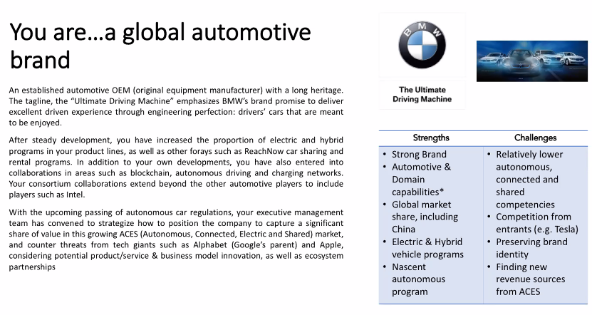

- BMW,
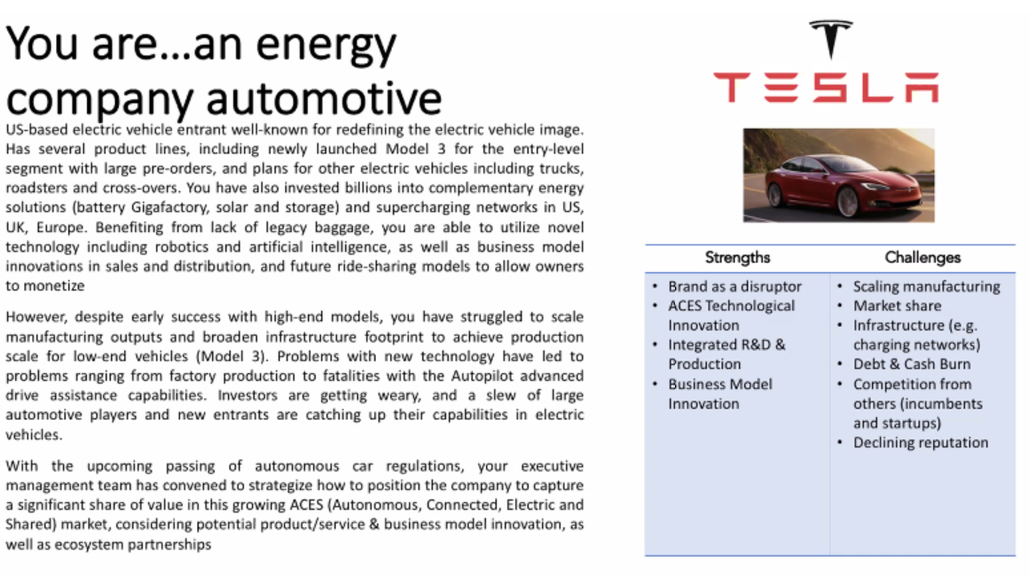
- Integration
- Providing batteries to other firms?

